ASSISTANCE LEAGUE® of Everett
Volunteers Serving Snohomish County Since 1965^{sm}

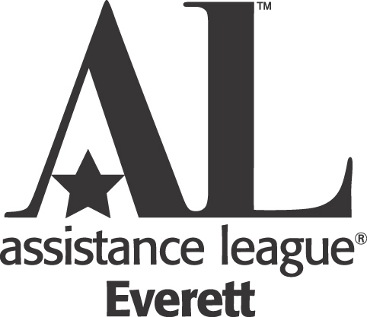

Graduation Award Application - Class of 2021
Graduation Awards of up to $200 per student are to be used for senior year graduation expenses. (Examples; cap & gown, senior party/trip, announcements, pictures senior projects, etc.) Financial need is the main criterion for this award. Completed applications must be returned to the school advisor/counselor for their signature and completion. Application must be received by Assistance League no later than March 3rd, 2021. Applications received after that date will not be eligible.

Note: To be considered for this award ALL PARTS of the application must be completed.

Personal Information:
Student’s Name (Please print)___________________________________________________________
First Middle Last
Address___________________________________________________________________________
Street City State Zip Code
Telephone (____)_________________________ Date of Birth______________________________

School District ______________________________ High School _______________________________

Family Financial Information: (Confidential – for Graduation Award Committee only)
This information should apply to the person(s) responsible for your financial welfare; such as parents, foster parents, or guardians. If you are living on your own, please include only your income.

Father’s Name ____________________________ Employer __________________________
(Please print) First Last

Mother’s Name ___________________________ Employer __________________________
(Please print) First Last

Parents’ or Guardians’ Current Monthly Take Home Income $ __________________________
Is student working? YES _______ NO __________
If yes, what is the student’s Current Monthly Take Home Income $ ________________

Other Income (i.e., Child Support, Social Security, Unemployment, Etc.) $ ______________________
Total family Monthly Take Home Income from all sources $ ____________________________
Number of persons living in the home dependent upon this income, including yourself.
Adults _______________ Children ______________
(OVER PLEASE)

Describe any circumstances which make it difficult to finance your senior year expenses.
____________________________________________________________________________
____________________________________________________________________________
____________________________________________________________________________

The Graduation Award is based partly on leadership, service, job experience, citizenship, activities and interests, both in school and in the community. Please list below whatever you wish the review committee to know. (Attach separate sheet, if needed.)
____________________________________________________________________________
________________________________________________________________________________________________________________________________________________________

Please tell us what graduation expenses you need help with. ____________________________________________________________________________
____________________________________________________________________________
Parents/Student/Counselor/Advisor Statement and Signatures:
I have read the statements in this application and certify that, to the best of my knowledge, they are true.

____________ _______________________________ _________________________________
Date Signature of Student Signature of Parent or Guardian

____________ _______________________________ __________________________________
Date Print Name of Counselor/Advisor Signature of Counselor/Advisor

Counselor’s/Advisor’s Comments. (Please include any special circumstances. Your comments are very helpful, appreciated, and are given consideration)

High School Cumulative Grade Point Average (Must be included)

______________________________________________________________________
______________________________________________________________________
____________________________________________________________________________________________________________________________________________
Applications must be received by Assistance League no later than March 3, 2021.

Send applications to: Graduation Awards Committee
Assistance League of Everett
5107 Evergreen Way
Everett, WA 98203

